**PO Box 918**

**Goshen, IN 46527-0918**

**Phone: 1-888-406-3643**

**Email: info@mennohealth.org**

**Web: www.mennohealth.org**

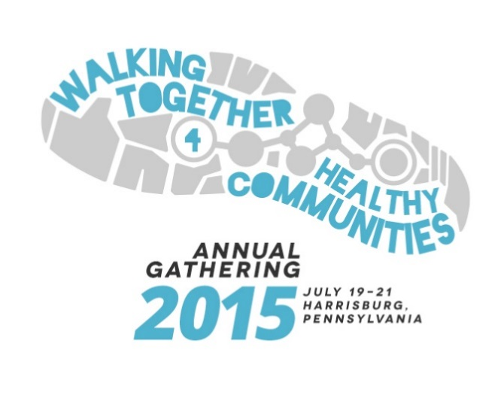**Annual Gathering Announcements 2015**

Choose and use freely in bulletins, newsletters, email messages, etc.

Also available (email [info@mennohealth.org](mailto:info@mennohealth.org)):

* Logo file – see left
* Bulletin Board flyer – 8.5 X 11 color
* Half-sheet insert – 5.5 X 8.5 color

For more details, contact MHF as above.

Feel free to add the following lines to any announcement below as appropriate: **Early registration deadline: April 15, 2015. Final registration deadline: June 28, 2015**

**Announcements**

**Come join** with doctors, nurses, dieticians, therapists, chaplains, mental health workers, and many other healthcare workers and their families from around the world! It's the **Mennonite Healthcare Fellowship (MHF) Annual Gathering**, July 19-21, 2015, immediately prior to Mennonite World Conference Global Assembly in Harrisburg, Pennsylvania. The theme is **"Walking Together for Healthy Communities."** Plenary presenters include Ted & Company, Shane Claiborne, and Dr. Ann Thyle from India. Grants are available for students, volunteers, and those from outside the U.S. and Canada. For more information and registration, go to *www.mennohealth/gathering*, email *info@mennohealth.org*, or call toll-free to 1-888-406-3643.

**Healthcare workers--past, present, and future:** Don't miss this event immediately prior to Mennonite World Conference Global Assembly! Bring the whole family to the **Mennonite Healthcare Fellowship (MHF) Annual Gathering**, July 19-21, 2015, in Harrisburg, Pennsylvania. The theme is "**Walking Together for Healthy Communities**." Plenary presenters include Ted & Company, Shane Claiborne, and Dr. Ann Thyle from India. Grants are available for students, volunteers, and those from outside the U.S. and Canada. Children and youth program for ages 0-18 provided. For more information and registration, go to *www.mennohealth/gathering*, email *info@mennohealth.org*, or call toll-free to 1-888-406-3643.

**Why does a young postgraduate anesthesiologist** on a career path towards being the next department head in a large teaching hospital choose to work in a small mission hospital at the foothills of the Himalayas? Hear Dr. Ann Thyle's journey of faith and medicine at the **Mennonite Healthcare Fellowship (MHF) Annual Gathering**, July 19-21, 2015, immediately prior to Mennonite World Conference Global Assembly in Harrisburg, Pennsylvania. The theme is "**Walking Together for Healthy Communities**." Healthcare workers, past, present, and future, and from all medical, mental, and spiritual health professions, are warmly invited to come and bring their families. Grants are available for students, volunteers, and those outside the U.S. and Canada. Children's program for ages 0-18. For more information and registration, go to *www.mennohealth/gathering*, email *info@mennohealth.org*, or call toll-free to 1-888-406-3643.

**Why should Anabaptist healthcare workers be concerned** about community health, the Lord's Supper, and persons with disabilities? Come and hear chaplain David Gullman contribute to the overall theme of "**Walking Together for Healthy Communities**" at the **Mennonite Healthcare Fellowship (MHF) Annual Gathering 2015**, July 19-21, in Harrisburg, Pennsylvania. All healthcare workers, past, present, and future, along with their families, are warmly invited. Grants are available for students, volunteers, and those outside the U.S. and Canada. Annual Gathering is a family-friendly event with a children and youth program for ages 0-18. For more information and registration, go to *www.mennohealth/gathering*, email *info@mennohealth.org*, or call toll-free to 1-888-406-3643.

**How does your faith integrate with your work in the healthcare field?** Mennonite Healthcare Fellowship (MHF) invites all healthcare workers, past, present, and future, and from medical, mental health, and chaplaincy professions, to come, along with their families, to its **Annual Gathering 2015**, July 19-21, 2015, in Harrisburg, Pennsylvania. Come to learn, fellowship, worship, network, and be encouraged in your Christian faith! Annual Gathering is a family-friendly event with a children's program for ages 0-18. Grants are available for students, volunteers, and those outside the U.S. and Canada. For more information and registration, go to *www.mennohealth/gathering*, email *info@mennohealth.org*, or call toll-free to 1-888-406-3643.

**How do we develop healthy communities?** Who gets to be part of those communities? Laugh, cry, think, and be inspired by **Ted & Co., Shane Claiborne**, and others! Learn, fellowship, and be inspired by colleagues from around the world! It all happens at the **Mennonite Healthcare Fellowship (MHF) Annual Gathering 2015**, July 19-21, 2015, in Harrisburg, Pennsylvania. All healthcare workers, past, present, and future, from medical, mental health, and chaplaincy professions, along with their families are warmly invited. Grants are available for students, volunteers, and those outside the U.S. and Canada. A children and youth program is available for ages 0-18. For more information and registration, go to *www.mennohealth/gathering*, email *info@mennohealth.org*, or call 1-888-406-3643 (toll-free).

**Where can you learn** about AIDS prevention in Kenya, gun control in the U.S., reducing maternal mortality in Tanzania, church-based health ministries from Latin America to Lancaster County, and the effect of climate change on global health? It's all a part of the **Mennonite Healthcare Fellowship (MHF) Annual Gathering** 2015, July 19-21, 2015, in Harrisburg, Pennsylvania. All healthcare workers, past, present, and future, from medical, mental health, and chaplaincy professions along with their families are warmly invited. Grants are available for students, volunteers, and those outside the U.S. and Canada. Children and youth program available for ages 0-18. For more information and registration, go to *www.mennohealth/gathering*, email *info@mennohealth.org*, or call 1-888-406-3643 (toll-free).

Mennonite Healthcare Fellowship

As of 2/11/2015

info@mennohealth.org