PO Box 918
Goshen, IN 46527-0918
Phone: 1-888-406-3643
Email: info@mennohealth.org
Web: www.mennohealth.org

Annual Gathering 2015 Cost Sharing Reference Form
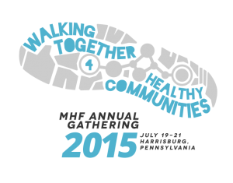
Annual Gathering 2015 brings healthcare workers from around the world to gather for fellowship, learning, inspiration, worship, and networking! It will be held July 19-21, 2015 in Harrisburg, Pennsylvania, USA, immediately prior to Mennonite World Conference Global Assembly.
Grant Applicant: Fill in your name and profession and give/send to a reference person who can verify your interest in attending the Mennonite Healthcare Fellowship (MHF) Annual Gathering and your financial need to make that possible. This person could be a pastor, mentor, or healthcare colleague.

Reference Person: Please fill out the rest of form below and send to Mennonite Healthcare Fellowship, PO Box 918, Goshen, IN 46527-0918 USA or to info@mennohealth.org.

Applicant Name: Click here to enter text.
Healthcare profession: Click here to enter text.

Reference Name: Click here to enter text.
Profession/Role: Click here to enter text.
Relationship to applicant: Click here to enter text.How long? Click here to enter text.
Address: Click here to enter text.
Phone (or voice app): Click here to enter text. E-mail: Click here to enter text.

How will attending the MHF Annual Gathering be meaningful or benefit the applicant from a professional and/or faith perspective?
Click here to enter text.

Applicant is applying to subsidize costs of meals and lodging for this 3-day, 2-night event.

Does this person have funding to travel to Harrisburg in July 2015?
Click here to enter text.

If coming from outside the U.S., can this person secure a visa to travel for this meeting?
Click here to enter text.

Does this person need financial assistance for the costs of meals and lodging (up to approximately US$300)?
Click here to enter text.

Are there any special considerations?
Click here to enter text.

